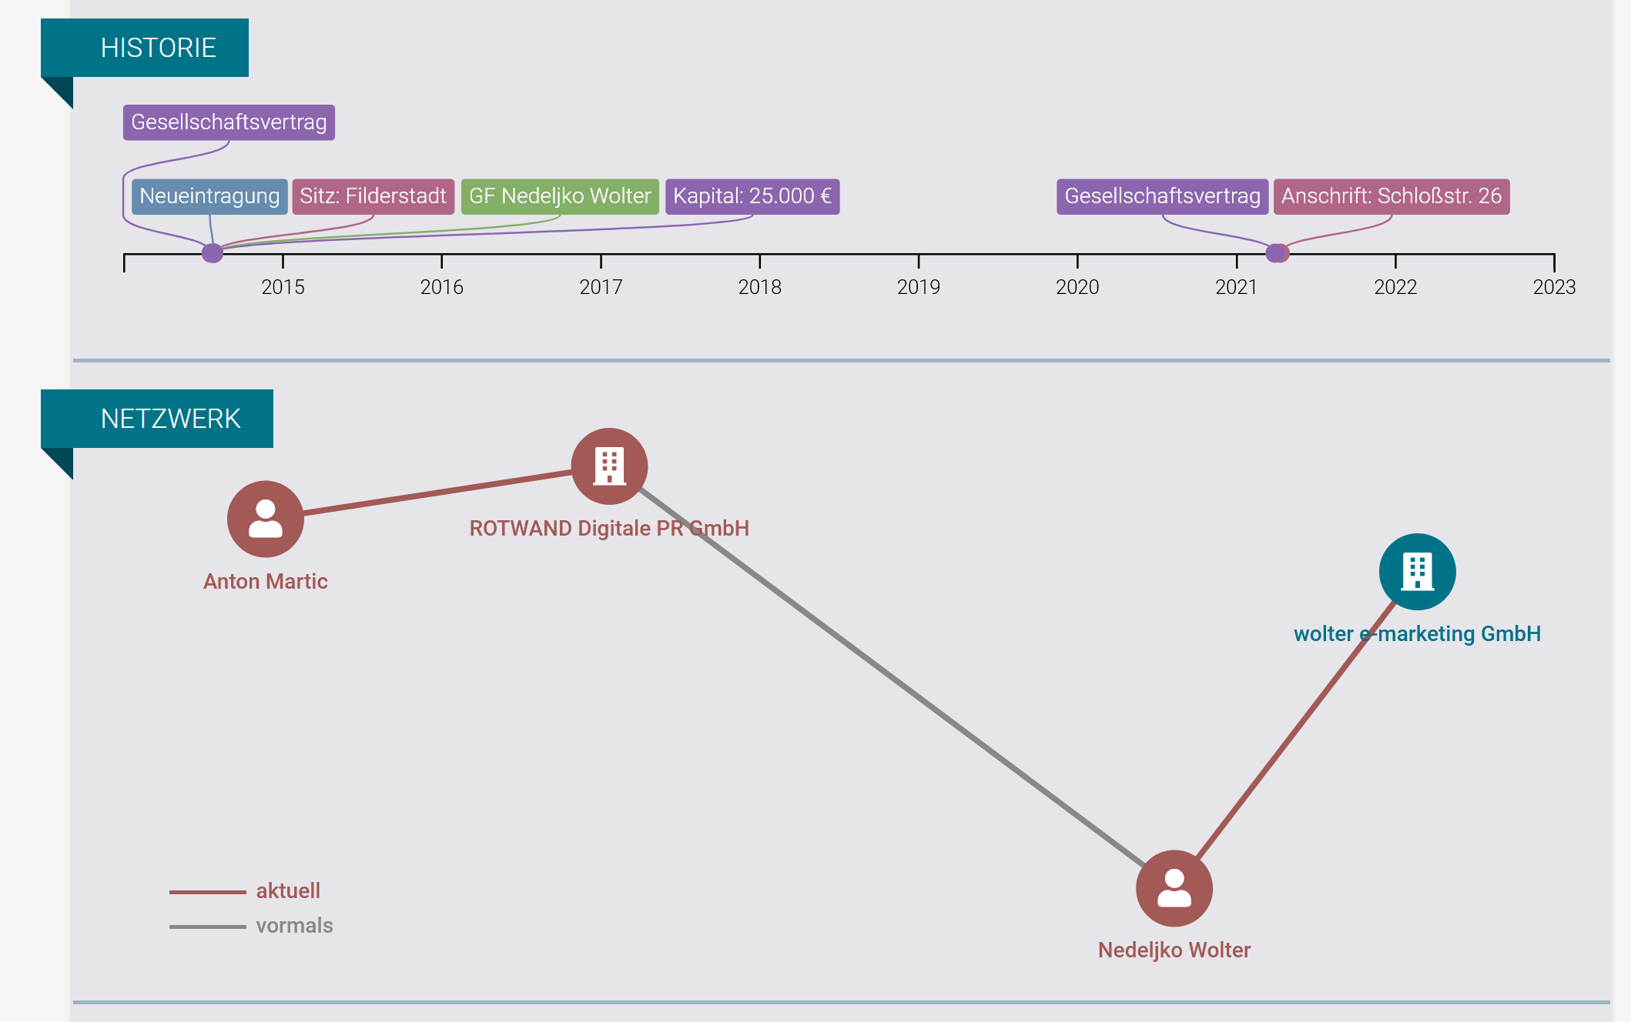



Nedeljko Wolter hat ein premium-Konto.



**Nedeljko Wolter**

Kontakt 3. Grades 3.

CEO at Wolter E-Marketing GmbH

* [[](https://www.linkedin.com/in/nedeljko-wolter/?originalSubdomain=de#experience)](https://www.linkedin.com/in/nedeljko-wolter/?originalSubdomain=de" \l "experience)

**[Wolter E-Marketing GmbH](https://www.linkedin.com/in/nedeljko-wolter/?originalSubdomain=de" \l "experience)**

**[Steinbeis Hochschule Berlin](https://www.linkedin.com/in/nedeljko-wolter/?originalSubdomain=de" \l "education)**

Neuhausen auf den Fildern, Baden-Württemberg, Deutschland [Kontaktinformationen](https://www.linkedin.com/in/nedeljko-wolter/overlay/contact-info/)

* 500+ Kontakte

[Nachricht](https://www.linkedin.com/messaging/thread/new?recipients=List(urn%3Ali%3Afsd_profile%3AACoAAAvS-x4BiW8qpc9-13YI749YXOvjkq2lt8E)&composeOptionType=PREMIUM_INMAIL&controlUrn=topcard_primary_compose_message_button&referringModuleKey=NON_SELF_PROFILE_VIEW&messageComposeFlowTrackingId=6RMySdiBSrKL7v4MUii9Mw%3D%3D)

* • • • • • • • • •

**Im FokusIm Fokus**

[BeitragBeitrag](https://www.linkedin.com/feed/update/urn:li:activity:6940625726412869633?updateEntityUrn=urn%3Ali%3Afs_feedUpdate%3A%28V2%2Curn%3Ali%3Aactivity%3A6940625726412869633%29" \t "_self)

[Yes! We did it! The](https://www.linkedin.com/feed/update/urn:li:activity:6940625726412869633?updateEntityUrn=urn%3Ali%3Afs_feedUpdate%3A%28V2%2Curn%3Ali%3Aactivity%3A6940625726412869633%29" \t "_self) [Syntegon](https://www.linkedin.com/company/syntegon/) Website is now on [HubSpot](https://www.linkedin.com/company/hubspot/) ! Thanks to the whole Syntegon Team! It was a great project!  
[Hashtag #hubspot](https://www.linkedin.com/feed/hashtag/hubspot/) [Hashtag #cms](https://www.linkedin.com/feed/hashtag/cms/) [Hashtag #welovehubspot](https://www.linkedin.com/feed/hashtag/welovehubspot/)

[[](https://www.linkedin.com/feed/update/urn:li:activity:6940625726412869633?updateEntityUrn=urn%3Ali%3Afs_feedUpdate%3A%28V2%2Curn%3Ali%3Aactivity%3A6940625726412869633%29)](https://www.linkedin.com/feed/update/urn:li:activity:6940625726412869633?updateEntityUrn=urn%3Ali%3Afs_feedUpdate%3A%28V2%2Curn%3Ali%3Aactivity%3A6940625726412869633%29" \t "_self)

•

•

[BeitragBeitrag](https://www.linkedin.com/feed/update/urn:li:activity:6909396972839858176?updateEntityUrn=urn%3Ali%3Afs_feedUpdate%3A%28V2%2Curn%3Ali%3Aactivity%3A6909396972839858176%29" \t "_self)

[Yes! 🙌🏻👏🏻🏆🎉](https://www.linkedin.com/feed/update/urn:li:activity:6909396972839858176?updateEntityUrn=urn%3Ali%3Afs_feedUpdate%3A%28V2%2Curn%3Ali%3Aactivity%3A6909396972839858176%29" \t "_self)

[[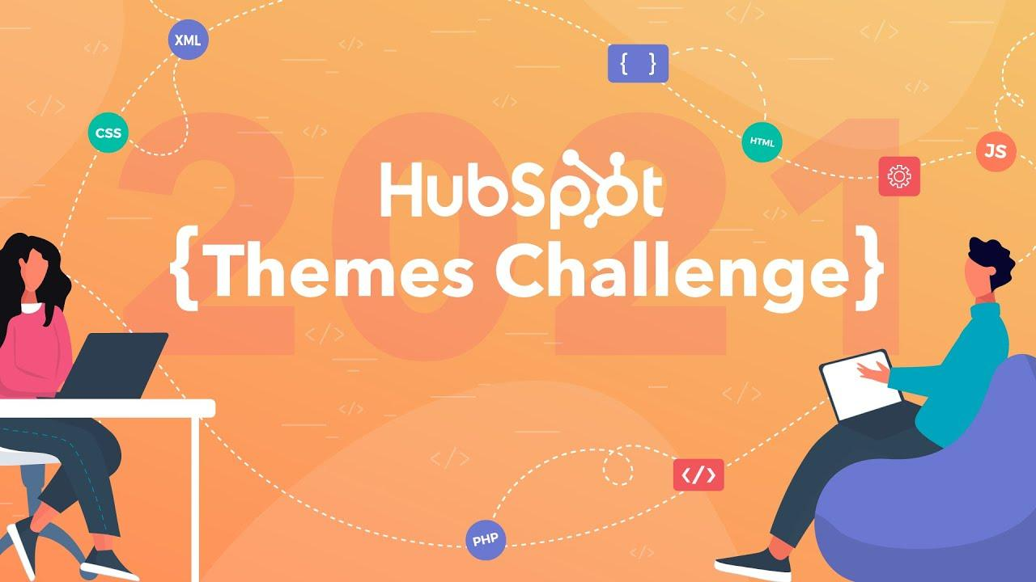](https://www.linkedin.com/feed/update/urn:li:activity:6909396972839858176?updateEntityUrn=urn%3Ali%3Afs_feedUpdate%3A%28V2%2Curn%3Ali%3Aactivity%3A6909396972839858176%29)](https://www.linkedin.com/feed/update/urn:li:activity:6909396972839858176?updateEntityUrn=urn%3Ali%3Afs_feedUpdate%3A%28V2%2Curn%3Ali%3Aactivity%3A6909396972839858176%29" \t "_self)

[We made it! WEM zählt zu den Top 20 bei der HubSpot Themes Challenge 2021](https://www.linkedin.com/feed/update/urn:li:activity:6909396972839858176?updateEntityUrn=urn%3Ali%3Afs_feedUpdate%3A%28V2%2Curn%3Ali%3Aactivity%3A6909396972839858176%29" \t "_self)

[w-em.com • Lesedauer: 2 Min.](https://www.linkedin.com/feed/update/urn:li:activity:6909396972839858176?updateEntityUrn=urn%3Ali%3Afs_feedUpdate%3A%28V2%2Curn%3Ali%3Aactivity%3A6909396972839858176%29" \t "_self)

**AktivitätenAktivitäten**

612 Follower:innen612 Follower:innen

**[Nedeljko Wolter](https://www.linkedin.com/feed/update/urn:li:activity:6950437689238147072?updateEntityUrn=urn%3Ali%3Afs_updateV2%3A%28urn%3Ali%3Aactivity%3A6950437689238147072%2CFEED_DETAIL%2CEMPTY%2CDEFAULT%2Cfalse%29)** [hat einen Beitrag kommentiert • 3 Wochen3 Wochen](https://www.linkedin.com/feed/update/urn:li:activity:6950437689238147072?updateEntityUrn=urn%3Ali%3Afs_updateV2%3A%28urn%3Ali%3Aactivity%3A6950437689238147072%2CFEED_DETAIL%2CEMPTY%2CDEFAULT%2Cfalse%29)

[Thank you Christoph Ammann for the great & smooth collaboration. Well done together!](https://www.linkedin.com/feed/update/urn:li:activity:6950437689238147072?updateEntityUrn=urn%3Ali%3Afs_updateV2%3A%28urn%3Ali%3Aactivity%3A6950437689238147072%2CFEED_DETAIL%2CEMPTY%2CDEFAULT%2Cfalse%29)

• •

**[Nedeljko Wolter](https://www.linkedin.com/feed/update/urn:li:activity:6950437477090246656?updateEntityUrn=urn%3Ali%3Afs_updateV2%3A%28urn%3Ali%3Aactivity%3A6950437477090246656%2CFEED_DETAIL%2CEMPTY%2CDEFAULT%2Cfalse%29)** [hat einen Beitrag geteilt • 3 Wochen3 Wochen](https://www.linkedin.com/feed/update/urn:li:activity:6950437477090246656?updateEntityUrn=urn%3Ali%3Afs_updateV2%3A%28urn%3Ali%3Aactivity%3A6950437477090246656%2CFEED_DETAIL%2CEMPTY%2CDEFAULT%2Cfalse%29)

[[](https://www.linkedin.com/feed/update/urn:li:activity:6950437477090246656?updateEntityUrn=urn%3Ali%3Afs_updateV2%3A%28urn%3Ali%3Aactivity%3A6950437477090246656%2CFEED_DETAIL%2CEMPTY%2CDEFAULT%2Cfalse%29)](https://www.linkedin.com/feed/update/urn:li:activity:6950437477090246656?updateEntityUrn=urn%3Ali%3Afs_updateV2%3A%28urn%3Ali%3Aactivity%3A6950437477090246656%2CFEED_DETAIL%2CEMPTY%2CDEFAULT%2Cfalse%29)

[Thank you](https://www.linkedin.com/feed/update/urn:li:activity:6950437477090246656?updateEntityUrn=urn%3Ali%3Afs_updateV2%3A%28urn%3Ali%3Aactivity%3A6950437477090246656%2CFEED_DETAIL%2CEMPTY%2CDEFAULT%2Cfalse%29) [Christoph Ammann](https://www.linkedin.com/in/ACoAAB3nC8gBgqfKo0FPNBKSacjb0eeH41-K2fY) for the great & smooth collaboration. Well done together! [Hashtag #hubspot](https://www.linkedin.com/feed/hashtag/hubspot/) [Hashtag #cms](https://www.linkedin.com/feed/hashtag/cms/) [Hashtag #welovehubspot](https://www.linkedin.com/feed/hashtag/welovehubspot/) // [Wolter E-Marketing GmbH](https://www.linkedin.com/company/wolter-e-marketing-gmbh/)

[Alle Aktivitäten anzeigen](https://www.linkedin.com/in/nedeljko-wolter/recent-activity/" \t "_self)

**BerufserfahrungBerufserfahrung**

[[](https://www.linkedin.com/company/12350858/)](https://www.linkedin.com/company/12350858/" \t "_self)

CEOCEO

Wolter E-Marketing GmbHWolter E-Marketing GmbH Jan. 2010–Heute · 12 Jahre 8 MonateJan. 2010–Heute · 12 Jahre 8 Monate Stuttgart und Umgebung, DeutschlandStuttgart und Umgebung, Deutschland

* + - Digital-Marketing Agency for Inbound-Marketing (HubSpot), Search Engine Optimization, Performance-Marketing & Usability, https://w-em.comDigital-Marketing Agency for Inbound-Marketing (HubSpot), Search Engine Optimization, Performance-Marketing & Usability, https://w-em.com

CEOCEO

ROTWAND | Digitale PR GmbHROTWAND | Digitale PR GmbH Jan. 2015–Dez. 2019 · 5 JahreJan. 2015–Dez. 2019 · 5 Jahre Munich Area, GermanyMunich Area, Germany

* + - Digital PR Agency http://www.rotwand.netDigital PR Agency http://www.rotwand.net

Head of Project ManagementHead of Project Management

media access GmbHmedia access GmbH Okt. 2005–Dez. 2009 · 4 Jahre 3 MonateOkt. 2005–Dez. 2009 · 4 Jahre 3 Monate

Project Manager / ConsultantProject Manager / Consultant

Star CooperationStar Cooperation Sept. 2002–Sept. 2005 · 3 Jahre 1 MonatSept. 2002–Sept. 2005 · 3 Jahre 1 Monat

**AusbildungAusbildung**

[Steinbeis Hochschule BerlinSteinbeis Hochschule Berlin](https://www.linkedin.com/search/results/all/?keywords=Steinbeis+Hochschule+Berlin" \t "_self)

[Master of Business Administration (M.B.A.)Master of Business Administration (M.B.A.)](https://www.linkedin.com/search/results/all/?keywords=Steinbeis+Hochschule+Berlin" \t "_self)

[Middlesex University LondonMiddlesex University London](https://www.linkedin.com/search/results/all/?keywords=Middlesex+University+London" \t "_self)

[Bachelor of Arts (B.A.)Bachelor of Arts (B.A.)](https://www.linkedin.com/search/results/all/?keywords=Middlesex+University+London" \t "_self)

**KenntnisseKenntnisse**

* SEOSEO
* •

[9 Kenntnisbestätigungen9 Kenntnisbestätigungen](https://www.linkedin.com/in/nedeljko-wolter/details/skills/urn:li:fsd_skill:(ACoAAAvS-x4BiW8qpc9-13YI749YXOvjkq2lt8E,14)/endorsers?profileUrn=urn%3Ali%3Afsd_profile%3AACoAAAvS-x4BiW8qpc9-13YI749YXOvjkq2lt8E&tabIndex=0&modalTabIndex=0&detailScreenTabIndex=0" \t "_self)

• Online MarketingOnline Marketing

* •

[7 Kenntnisbestätigungen7 Kenntnisbestätigungen](https://www.linkedin.com/in/nedeljko-wolter/details/skills/urn:li:fsd_skill:(ACoAAAvS-x4BiW8qpc9-13YI749YXOvjkq2lt8E,12)/endorsers?profileUrn=urn%3Ali%3Afsd_profile%3AACoAAAvS-x4BiW8qpc9-13YI749YXOvjkq2lt8E&tabIndex=0&modalTabIndex=0&detailScreenTabIndex=0" \t "_self)

• Online AdvertisingOnline Advertising

[3 Kenntnisbestätigungen3 Kenntnisbestätigungen](https://www.linkedin.com/in/nedeljko-wolter/details/skills/urn:li:fsd_skill:(ACoAAAvS-x4BiW8qpc9-13YI749YXOvjkq2lt8E,2)/endorsers?profileUrn=urn%3Ali%3Afsd_profile%3AACoAAAvS-x4BiW8qpc9-13YI749YXOvjkq2lt8E&tabIndex=0&modalTabIndex=0&detailScreenTabIndex=0" \t "_self)

[Alle 15 Kenntnisse anzeigen](https://www.linkedin.com/in/nedeljko-wolter/details/skills?profileUrn=urn%3Ali%3Afsd_profile%3AACoAAAvS-x4BiW8qpc9-13YI749YXOvjkq2lt8E" \t "_self)

**InteressenInteressen**

[[](https://www.linkedin.com/in/julia-jaekel)](https://www.linkedin.com/in/julia-jaekel" \t "_self)

[Julia JaekelJulia Jaekel](https://www.linkedin.com/in/julia-jaekel" \t "_self)

•

[· 3.Kontakt 3. Grades](https://www.linkedin.com/in/julia-jaekel" \t "_self)

[Linkedin Top Voice | Non Executive Director | Aufsichtsrätin | Former CEO Gruner+Jahr 2012-2021 + Member of the Bertelsmann Group Management CommitteeLinkedin Top Voice | Non Executive Director | Aufsichtsrätin | Former CEO Gruner+Jahr 2012-2021 + Member of the Bertelsmann Group Management Committee 87.344 Follower:innen87.344 Follower:innen](https://www.linkedin.com/in/julia-jaekel" \t "_self)

•

[[](https://www.linkedin.com/in/frank-thelen)](https://www.linkedin.com/in/frank-thelen" \t "_self)

[Frank ThelenFrank Thelen](https://www.linkedin.com/in/frank-thelen" \t "_self)

[· 2.Kontakt 2. Grades](https://www.linkedin.com/in/frank-thelen" \t "_self)

[European Early Stage Tech Investor | Venture Capital | Disruption | Technologie | 10xDNA | Startup-DNA | DHDLEuropean Early Stage Tech Investor | Venture Capital | Disruption | Technologie | 10xDNA | Startup-DNA | DHDL 471.096 Follower:innen](https://www.linkedin.com/in/frank-thelen" \t "_self)